SYSTEM DESCRIPTION
Included as Section 3, SOC Report

COMPANY BACKGROUND
Sensor Global (the “company”) was founded in 2021 by Cameron Davis to provide IoT Smart smoke alarms to the property management industry. The organization is based out of West Gosford NSW, Australia.

DESCRIPTION OF SERVICES OVERVIEW OR SERVICES PROVIDED
Sensor Global’s core product, Sensor Ecosystem (the “system”) is a Software as a Service (SaaS) solution that includes the following services:
- Sensor Global Live cloud software platform
- Sensor Hub
- Sensor Smoke Alarm
- Water Leak Detector

PRINCIPAL SERVICE COMMITMENTS AND SYSTEM REQUIREMENTS
Sensor Global designs its processes and procedures related to the system to meet its objectives. Those objectives are based on the service commitments that Sensor Global makes to user entities, the laws, and regulations that govern the provision of the services, and the financial, operational, and compliance requirements that Sensor Global has established for the services. The system services are subject to the Security, Confidentiality, Availability, Processing Integrity, and/or Privacy commitments established internally for its services. Commitments to user entities are documented and communicated in Service Level Agreements (SLAs) and other customer agreements, as well as in the description of the service offering provided online.

Security commitments include, but are not limited to, the following:
- System features and configuration settings designed to authorize user access while restricting unauthorized users from accessing information not needed for their role;
- Use of intrusion detection systems to prevent and identify potential security attacks from users outside the boundaries of the system;
- Regular vulnerability scans over the system and network, and penetration tests over the production environment; and,
- Operational procedures for managing security incidents and breaches, including notification procedures.
- Use of encryption technologies to protect customer data both at rest and in transit
- Use of data retention and data disposal
- Uptime availability of production systems
Confidentiality commitments include, but are not limited to, the following:
- The use of encryption technologies to protect system data both at rest and in transit;
- Confidentiality and non-disclosure agreements with employees, contractors, and third parties; and,
- Confidential information must be used only for the purposes explicitly stated in agreements between Sensor Global and user entities.
Availability commitments include, but are not limited to, the following:
- System performance and availability monitoring mechanisms to help ensure the consistent delivery of the system and its components;
- Responding to customer requests in a reasonably timely manner;
- Business continuity and disaster recovery plans that include detailed instructions, recovery point objectives (RPOs), recovery time objectives (RTOs), roles, and responsibilities; and,
- Operational procedures supporting the achievement of availability commitments to user entities.

COMPONENTS OF THE SYSTEM

The System description is comprised of the following components:
- Infrastructure – The collection of physical or virtual resources that supports an overall IT environment, including the physical environment and related structures, IT and hardware (for example, facilities, servers, storage, environmental monitoring equipment, data storage devices and media, mobile devices, and internal networks and connected external telecommunications networks) that the service organization used to provide the services.
- Software - The application programs and IT system software that supports application programs (operating systems, middleware, and utilities), the types of databases used, the nature of external facing web applications, and the nature of applications developed in-house, including details about whether the applications in use are mobile applications or desktop or laptop applications.
- People - The personnel involved in the governance, operation, security, and use of a system (business unit personnel, developers, operators, user entity personnel, vendor personnel, and managers).
- Data – The types of data used by the system, such as transaction streams, files, databases, tables, and output used or processed by the system.
- Procedures – The automated and manual procedures related to the services provided, including, as appropriate, procedures by which service activities are initiated, authorized, performed, and delivered, and reports and other information prepared.
INFRASTRUCTURE

Sensor Global maintains a system inventory that includes virtual machines, computers (desktops and laptops), and networking devices (switches and routers). The inventory documents device name, inventory type, description and owner. To outline the topology of its network, the organization maintains the following network diagram(s).
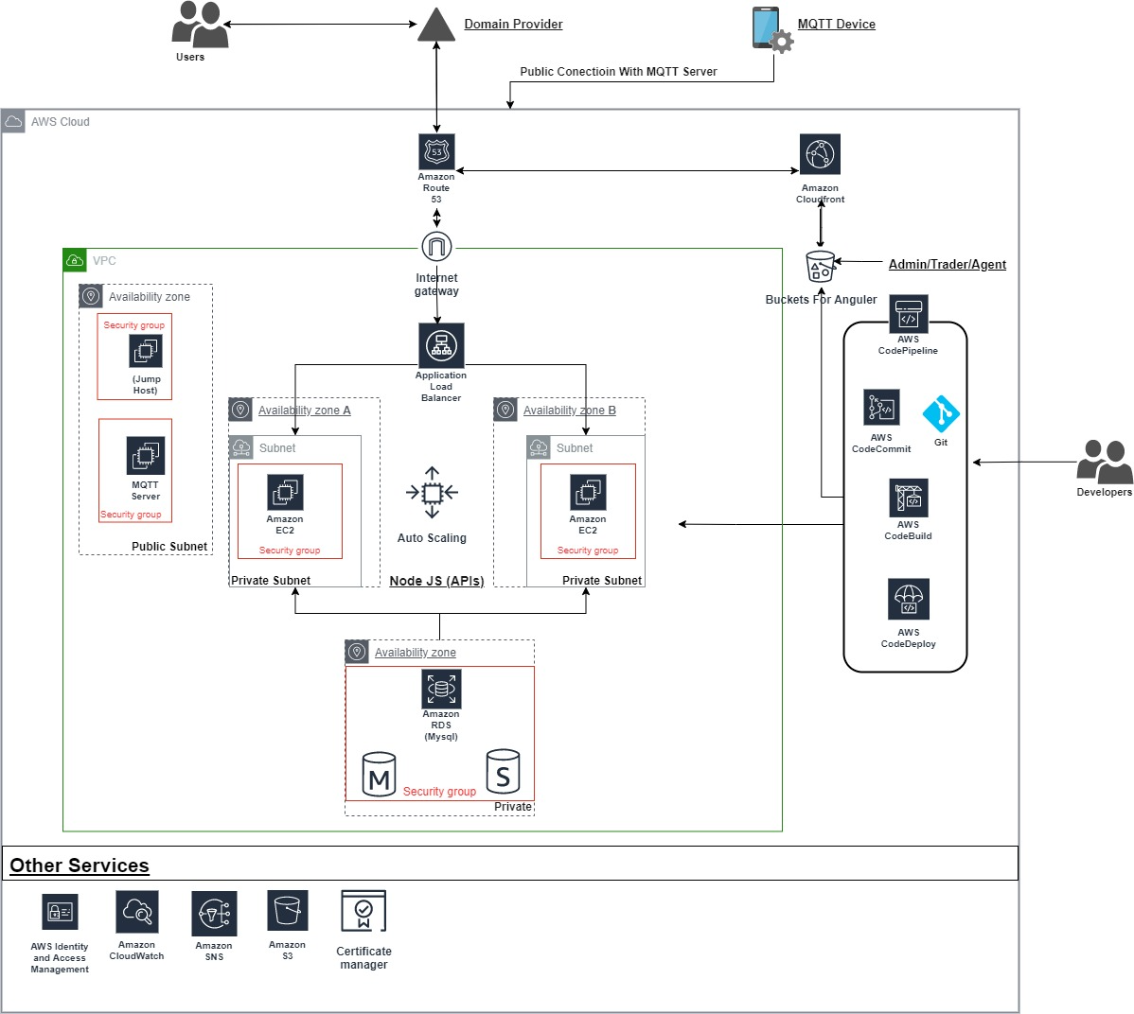

Primary Infrastructure
Hardware | Type | Purpose
AWS Elastic Compute Cloud (EC2) | AWS
AWS Elastic Load Balancers | AWS | Load balance internal and external traffic
Virtual Private Cloud | AWS | Protects the network perimeter and restricts inbound and outbound access
S3 Buckets | AWS | Storage, upload and download

SOFTWARE
Sensor Global is responsible for managing the development and operation of the Sensor platform including infrastructure components such as servers, databases, and storage systems. The in-scope Sensor Global infrastructure and software components are shown in the table below:

Primary Software
System/Application | Operating System | Purpose
GuardDuty | AWS | Security application used for automated intrusion detection (IDS)

PEOPLE

The company employs dedicated team members to handle major product functions, including operations, and support. The IT/Engineering Team monitors the environment, as well as manages data backups and recovery. The Company focuses on hiring the right people for the right job as well as training them both on their specific tasks and on the ways to keep the company and its data secure.
Sensor Global has a staff of approximately 15, organised in the following functional areas:

Management - Individuals who are responsible for enabling other employees to perform their jobs effectively and for maintaining security and compliance across the environment.
CEO – Andrew Cox
COO – Tom McEvoy
Software Development Manager – Sam Collins

Operations - Responsible for maintaining the availability of production infrastructure and managing access and security for production infrastructure. Only members of the Operations team have access to the production environment. Members of the Operations team may also be members of the Engineering team.

Information Technology - Responsible for managing laptops, software, and other technology involved in employee productivity and business operations.

Product Development - Responsible for the development, testing, deployment, and maintenance of the source code for the system. Responsible for the product life cycle, including adding additional product functionality.

DATA

Data as defined by Sensor Global, constitutes the following:
- Personally identifiable information
- Company information
- Product usage information
Data is categorized in four major types of data used by Sensor Global

Category | Description | Examples
Public | Public information is not confidential and can be made public without any implications for Sensor Global. | - Press releases  - Public website
Internal | Access to internal information is approved by management and is protected from external access. | - Internal memos  - Design documents  - Product specifications  - Correspondences
Customer data | Information received from customers for processing or storage by Sensor Global.  Sensor Global must uphold the highest possible levels of integrity, confidentiality, and restricted availability for this information. | - Customer operating data  - Customer PII  - Customers' customers' PII  - Anything subject to a confidentiality agreement with a customer
Company data | Information collected and used by Sensor Global to operate the business. Sensor Global must uphold the highest possible levels of integrity, confidentiality, and restricted availability for this information. | - Legal documents  - Contractual agreements  - Employee PII  - Employee salaries

Customer data is managed, processed, and stored in accordance with the relevant data protection and other regulations, with specific requirements formally established in customer agreements, if any. Customer data is captured which is utilized by the company in delivering its services.
All employees and contractors of the company are obligated to respect and, in all cases, to protect customer data. Additionally, Sensor Global has policies and procedures in place to ensure proper and secure handling of customer data. These policies and procedures are reviewed on at least an annual basis.

PROCESSES AND PROCEDURES
Management has developed and communicated policies and procedures to manage the information security of the system. Changes to these procedures are performed annually and authorized by the Software Development Manager. These procedures cover the following key security life cycle areas:
- Physical Security
- Logical Access
- Availability
- Change Control
- Data Communications
- Risk Assessment
- Data Retention
- Vendor Management

PHYSICAL SECURITY

Sensor Global’s production servers are maintained by AWS. The physical and environmental security protections are the responsibility of AWS. Sensor Global reviews the attestation reports and performs a risk analysis of AWS on at least an annual basis.

LOGICAL ACCESS

Sensor Global provides employees and contracts access to infrastructure via a role-based access control system, to ensure uniform, least privilege access to identified users and to maintain simple and reportable user provisioning and deprovisioning processes.

Access to these systems is split into four levels; Administrator, User, Read Only, and No Access. User access and roles are reviewed on an annual basis to ensure least privilege access.

Management is responsible for provisioning access to the system based on the employee’s role and performing a background check. The employee is responsible for reviewing Sensor Global’s policies, completing security training. These steps must be completed within 14 days of hire.

When an employee is terminated, Management is responsible for deprovisioning access to all in scope systems within 3 days for that employee’s termination.

COMPUTER OPERATIONS - BACKUPS

Customer data is backed up and monitored by the Software Engineering team for completion and exceptions. If there is an exception Software Engineering team perform troubleshooting to identify the root cause and either rerun the backup or as part of the next scheduled backup job.

Backup infrastructure is maintained in AWS with physical access restricted according to the policies. Backups are encrypted, with access restricted to key personnel.

COMPUTER OPERATIONS - AVAILABILITY

Sensor Global maintains an incident response plan to guide employees on reporting and responding to any information security or data privacy events or incidents. Procedures are in place for identifying, reporting and acting upon breaches or other incidents.

Sensor Global internally monitors all applications, including the web UI, databases, and cloud storage to ensure that service delivery matches SLA requirements.

Sensor Global utilizes vulnerability scanning software that checks source code for common security issues as well as for vulnerabilities identified in open-source dependencies and maintains an internal SLA for responding to those issues.

CHANGE MANAGEMENT

Sensor Global maintains documented Systems Development Life Cycle (SDLC) policies and procedures to guide personnel in documenting and implementing application and infrastructure changes. Change control procedures include change request and initiation processes, documentation requirements, development practices, quality assurance testing requirements, and required approval procedures.

A ticketing system is utilized to document the change control procedures for changes in the application and implementation of new changes. Quality assurance testing and User Acceptance Testing (UAT) results are documented and maintained with the associated change request. Development and testing are performed in an environment that is logically separated from the production environment. Management approves changes prior to migration to the production environment and documents those approvals within the ticketing system.

Version control software is utilized to maintain source code versions and migrate source code through the development process to the production environment. The version control software maintains a history of code changes to support rollback capabilities and tracks changes to developers.

DATA COMMUNICATIONS

Sensor Global has elected to use a platform-as-a-service (PaaS) to run its production infrastructure in part to avoid the complexity of network monitoring, configuration, and operations. The PaaS simplifies our logical network configuration by providing an effective firewall around all the Sensor Global application containers, with the only ingress from the network via HTTPS connections to designated web frontend endpoints.

The PaaS provider also automates the provisioning and deprovisioning of containers to match the desired configuration; if an application container fails, it will be automatically replaced, regardless of whether that failure is in the application or on underlying hardware.

Sensor Global engages an external security firm to perform ongoing vulnerability scans and annual penetration testing to look for unidentified vulnerabilities, and the product engineering team responds to any issues identified via the regular incident response and change management process.

BOUNDARIES OF THE SYSTEM

The scope of this report includes the Sensor system performed in AWS facilities and other locations.

Any Subservice organizations carved-out of the scope of the review - This report does not include the Cloud Hosting Services provided by AWS at multiple facilities.

RELEVANT ASPECTS OF THE CONTROL ENVIRONMENT, RISK ASSESSMENT PROCESS, INFORMATION AND COMMUNICATION, AND MONITORING

CONTROL ENVIRONMENT

INTEGRITY AND ETHICAL VALUES

The effectiveness of controls cannot rise above the integrity and ethical values of the people who create, administer, and monitor them. Integrity and ethical values are essential elements of Sensor Global's control environment, affecting the design, administration, and monitoring of other components. Integrity and ethical behaviour are the product of Sensor Global's ethical and behavioural standards, how they are communicated, and how they are reinforced in practices. They include management’s actions to remove or reduce incentives and temptations that might prompt personnel to engage in dishonest, illegal, or unethical acts. They also include the communication of entity values and behavioural standards to personnel through policy statements and codes of conduct, as well as by example.

Specific control activities that the service organization has implemented in this area are described below:

- Formally, documented organizational policy statements and codes of conduct communicate entity values and behavioural standards to personnel.
- Policies and procedures require employees sign an acknowledgment form indicating they have been given access to the employee manual and understand their responsibility for adhering to the policies and procedures contained within the manual.
- A confidentiality statement agreeing not to disclose proprietary or confidential information, including client information, to unauthorized parties is a component of the employee handbook.
- Background checks are performed for employees in sensitive roles as a component of the hiring process.

COMMITMENT TO COMPETENCE

Sensor Global's management defines competence as the knowledge and skills necessary to accomplish tasks that define employees’ roles and responsibilities. Management’s commitment to competence includes management’s consideration of the competence levels for jobs and how those levels translate into the requisite skills and knowledge.

Specific control activities that the service organization has implemented in this area are described below:

- Management has considered the competence levels for particular jobs and translated required skills and knowledge levels into written position requirements.
- Training is provided to maintain the skill level of personnel in certain positions.

MANAGEMENT'S PHILOSOPHY AND OPERATING STYLE

The Sensor Global management team must balance two competing interests: continuing to grow and develop in a cutting edge, rapidly changing technology space while remaining excellent and conservative stewards of the highly-sensitive data and workflows our customers entrust to us.

The management team meets frequently to be briefed on technology changes that impact the way Sensor Global can help customers build data workflows, as well as new security technologies that can help protect those workflows, and finally any regulatory changes that may require Sensor Global to alter its software to maintain legal compliance. Major planned changes to the business are also reviewed by the management team to ensure they can be conducted in a way that is compatible with our core product offerings and duties to new and existing customers.

Specific control activities that the service organization has implemented in this area are described below:

- Management is periodically briefed on regulatory and industry changes affecting the services provided.
- Executive management meetings are held to discuss major initiatives and issues that affect the business.

ORGANIZATIONAL STRUCTURE AND ASSIGNMENT OF AUTHORITY AND RESPONSIBILITY

Sensor Global's organizational structure provides the framework within which its activities for achieving entity-wide objectives are planned, executed, controlled, and monitored. Management believes establishing a relevant organizational structure includes considering key areas of authority and responsibility. An organizational structure has been developed to suit its needs. This organizational structure is based, in part, on its size and the nature of its activities.

Sensor Global's assignment of authority and responsibility activities include factors such as how authority and responsibility for operating activities are assigned and how reporting relationships and authorization hierarchies are established. It also includes policies relating to appropriate business practices, knowledge, and experience of key personnel, and resources provided for carrying out duties. In addition, it includes policies and communications directed at ensuring personnel understand the entity’s objectives, know how their individual actions interrelate and contribute to those objectives, and recognize how and for what they will be held accountable.

Specific control activities that the service organization has implemented in this area are described below:

- Organizational charts are in place to communicate key areas of authority and responsibility.
- Organizational charts are communicated to employees and updated as needed.

HUMAN RESOURCE POLICIES AND PRACTICES

Sensor Global's success is founded on sound business ethics, reinforced with a high level of efficiency, integrity, and ethical standards. The result of this success is evidenced by its proven track record for hiring and retaining top quality personnel who ensure the service organization operates at maximum efficiency. Sensor Global's human resources policies and practices relate to employee hiring, orientation, training, evaluation, counselling, promotion, compensation, and disciplinary activities.

Specific control activities that the service organization has implemented in this area are described below:

- New employee background check
- New employees are required to sign acknowledgement forms for the employee handbook and a confidentiality agreement following new hire orientation on their first day of employment.
- Evaluations for each employee are performed on an annual basis.
- Employee termination procedures are in place to guide the termination process and are documented in a termination checklist.

RISK ASSESSMENT PROCESS

Sensor Global’s risk assessment process identifies and manages risks that could potentially affect Sensor Global’s ability to provide reliable and secure services to our customers. As part of this process, Sensor Global maintains a risk register to track all systems and procedures that could present risks to meeting the company’s objectives. Risks are evaluated by likelihood and impact, and management creates tasks to address risks that score highly on both dimensions. The risk register is reevaluated annually, and tasks are incorporated into the regular Sensor Global product development process so they can be dealt with predictably and iteratively.

INTEGRATION WITH RISK ASSESSMENT

The environment in which the system operates; the commitments, agreements, and responsibilities of Sensor Global’s system; as well as the nature of the components of the system result in risks that the criteria will not be met. Sensor Global addresses these risks through the implementation of suitably designed controls to provide reasonable assurance that the criteria are met. Because each system and the environment in which it operates are unique, the combination of risks to meeting the criteria and the controls necessary to address the risks will be unique. As part of the design and operation of the system, Sensor Global’s management identifies the specific risks that the criteria will not be met and the controls necessary to address those risks.

INFORMATION AND COMMUNICATION SYSTEMS

Information and communication are an integral component of Sensor Global’s internal control system. It is the process of identifying, capturing, and exchanging information in the form and time frame necessary to conduct, manage, and control the entity’s operations.

Sensor Global uses several information and communication channels internally to share information with management, employees, contractors, and customers. Sensor Global uses chat systems and email as the primary internal and external communications channels.

Structured data is communicated internally via SaaS applications and project management tools. Finally, Sensor Global uses in-person and video “all hands” meetings to communicate company priorities and goals from management to all employees.

MONITORING CONTROLS

Management monitors controls to ensure that they are operating as intended and that controls are modified as conditions change. Sensor Global’s management performs monitoring activities to continuously assess the quality of internal control over time. Necessary corrective actions are taken as required to correct deviations from company policies and procedures. Employee activity and adherence to company policies and procedures is also monitored. This process is accomplished through ongoing monitoring activities, separate evaluations, or a combination of the two.

ON-GOING MONITORING

Sensor Global’s management conducts quality assurance monitoring on a regular basis and additional training is provided based upon results of monitoring procedures. Monitoring activities are used to initiate corrective action through department meetings, internal conference calls, and informal notifications.

Management’s close involvement in Sensor Global’s operations helps to identify significant variances from expectations regarding internal controls. Upper management evaluates the facts and circumstances related to any suspected control breakdown. A decision for addressing any control’s weakness is made based on whether the incident was isolated or requires a change in the company’s procedures or personnel. The goal of this process is to ensure legal compliance and to maximize the performance of Sensor Global’s personnel.

REPORTING DEFICIENCIES

Our internal risk management tracking tool is utilized to document and track the results of on-going monitoring procedures. Escalation procedures are maintained for responding and notifying management of any identified risks, and instructions for escalation are supplied to employees in company policy documents. Risks receiving a high rating are responded to immediately. Corrective actions, if necessary, are documented and tracked within the internal tracking tool. Annual risk meetings are held for management to review reported deficiencies and corrective actions.

CHANGES TO THE SYSTEM

Type 2:

No significant changes have occurred to the services provided to user entities during the review period or since the organization's last review.

INCIDENTS

Type 2:

No significant incidents have occurred to the services provided to user entities during the review period or since the organization's last review.

CRITERIA NOT APPLICABLE TO THE SYSTEM

All Common Criteria/Security, Availability, Processing Integrity, Confidentiality and Privacy criteria were applicable to the Sensor Global Sensor system.

SUBSERVICE ORGANIZATIONS

This report does not include the Cloud Hosting Services provided by AWS at multiple facilities.

Subservice Description of Services

The Cloud Hosting Services provided by AWS support the physical infrastructure of the entities services.

Subservice Provider – AWS
Category | Criteria | Control
Security | CC6.4 | Physical access to data centers is approved by an authorized individual.
Security | CC6.4 | Physical access is revoked within 24 hours of the employee or vendor record being deactivated.
Security | CC6.4 | Physical access to data centers is reviewed on a quarterly basis by appropriate personnel.
Security | CC6.4 | Closed circuit television camera (CCTV) are used to monitor server locations in data centers. Images are retained for 90 days, unless limited by legal or contractual obligations.
Security | CC6.4 | Access to server locations is managed by electronic access control devices.
Availability | A1.2 | AWS maintains formal policies that provide guidance for information security within the organization and the supporting IT environment.
Availability | A1.2 | AWS has a process in place to review environmental and geo-political risks before launching a new region.
Availability | A1.2 | Amazon-owned data centers are protected by fire detection and suppression systems.
Availability | A1.2 | Amazon-owned data centers are air conditioned to maintain appropriate atmospheric conditions. Personnel and systems monitor and control air temperature and humidity at appropriate levels.
Availability | A1.2 | Uninterruptible Power Supply (UPS) units provide backup power in the event of an electrical failure in Amazon owned data centers
Availability | A1.2 | Amazon-owned data centers have generators to provide backup power in case of electrical failure.
Availability | A1.2 | Contracts are in place with third-party colocation service providers which include provisions to provide fire suppression systems, air conditioning to maintain appropriate atmospheric conditions, Uninterruptible Power Supply (UPS) units, and redundant power supplies. Contracts also include provisions requiring communication of incidents or events that impact Amazon assets and/or customers to AWS.

Complementary Subservice Organization Controls

Sensor Global’s services are designed with the assumption that certain controls will be implemented by subservice organizations. Such controls are called complementary subservice organization controls. It is not feasible for all of the trust services criteria related to Sensor Global’s services to be solely achieved by Sensor Global control procedures. Accordingly, subservice organizations, in conjunction with the services, should establish their own internal controls or procedures to complement those of Sensor Global.

The following subservice organization controls have been implemented by TechNine and included in this report to provide additional assurance that the trust services criteria are met.

Sensor Global management, along with the subservice provider, define the scope and responsibility of the controls necessary to meet all the relevant trust services criteria through written contracts, such as service level agreements. In addition, Sensor Global performs monitoring of the subservice organization controls, including the following procedures
- Reviewing and reconciling output reports
- Holding periodic discussions with vendors and subservice organization(s)
- Reviewing attestation reports over services provided by vendors and subservice organization(s)

COMPLEMENTARY USER ENTITY CONTROLS

Sensor Global’s services are designed with the assumption that certain controls will be implemented by user entities. Such controls are called complementary user entity controls. It is not feasible for all the Trust Services Criteria related to Sensor Global’s services to be solely achieved by Sensor Global control procedures. Accordingly, user entities, in conjunction with the services, should establish their own internal controls or procedures to complement those of Sensor Global’s.

The following complementary user entity controls should be implemented by user entities to provide additional assurance that the Trust Services Criteria described within this report are met. As these items represent only a part of the control considerations that might be pertinent at the user entities’ locations, user entities’ auditors should exercise judgment in selecting and reviewing these complementary user entity controls.

- User entities are responsible for understanding and complying with their contractual obligations to Sensor Global.
- User entities are responsible for notifying Sensor Global of changes made to technical or administrative contact information.
- User entities are responsible for maintaining their own system(s) of record.
- User entities are responsible for ensuring the supervision, management, and control of the use of Sensor Global services by their personnel.
- User entities are responsible for developing their own disaster recovery and business continuity plans that address the inability to access or utilize Sensor Global services.
- User entities are responsible for providing Sensor Global with a list of approvers for security and system configuration changes for data transmission.
- User entities are responsible for immediately notifying Sensor Global of any actual or suspected information security breaches, including compromised user accounts, including those used for integrations and secure file transfers.

